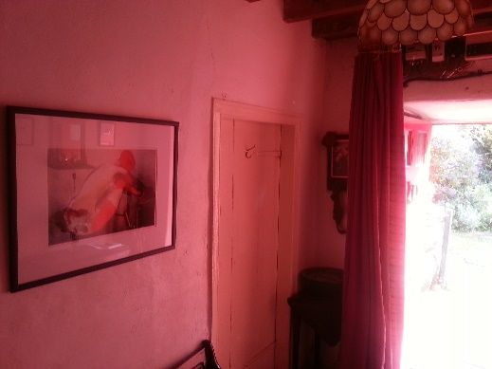
Red Thread Sangha 2015
Introduction
This year’s report is a little bit different from other years in that it includes all of the haiku written during the weekend. They are used them to illustrate the reportage in the way of a ‘haibun’, or maybe it is more of a ‘halibut’ as George’s spellcheck is wont to correct. Mindful of those who were unable to attend, there is a brief summary of presentations, some links and the papers. Also a couple of graces but no recipes. You had to be there to appreciate the food.
Absent friends
This year our numbers were depleted. Sadly Ken didn’t make it and as the weekend approached others had to pull out for health reasons - either their own or those of loved ones - or because of other more pressing challenges at home. Our thoughts and best wishes went out to all.

In the absence  of your warm welcome -  tentatively entering | Scattered clouds  and sporadic showers  our conversation broken
Undaunted  a snail scaling ridges  of the slate vase | Sunlight and the sound of water  through distant trees  birdsong
Those that did make it Jane Whittle’s farmhouse were George Marsh (Portsmouth), Stuart Quine (Sheffield), Sophie Muir (The Lizard), Martin Pitt (Dartmoor) and Jonathan Buckley(London).

Deep Valley  xxxxx xxxxx  No Signal! | Circling ducks  Conversations interrupted  Only by humans
warm  behind the mountain  the noble circle sits | the hearing aid  suddenly birdsong  widens the world

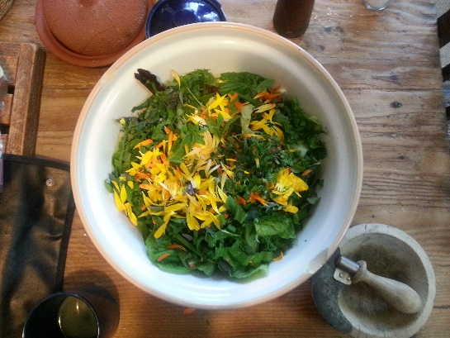
The Supreme Meal
‘since ancient times the office of cook in a Zen monastery has been held by realised monks who have the mind of the Way or by senior disciples who have roused the Way-seeking mind … indeed, Zen masters call a life that is lived fully and completely, with nothing held back, the supreme meal.’
(White Wind Zen Community)
Given the importance that the great Zen master Dogen attributed to the cook in a monastery, it seemed wholly appropriate that Ken handed over leadership of Red Thread Sangha retreat 2015 to George. As ever, George coaxed the slow and steady Aga stove to create a series of lovely meals that sustained the body and he also fuelledminds with his learned discourse.But first let us eat. Martin reminded us of the grace given by one Paul Seto:
‘Two, four, six, eight, tuck in don’t wait’.
On the Friday night it was noodles with mushrooms, intensified with Ceps, followed by pears baked in red wine and served with vanilla ice cream. There was a selection of hors d’oeuvres. And each morning we breakfasted on stewed fruits, muesli, flakes, toast, tea and coffee.
On Saturday, lunch was a baked potato served with red lentils cooked in a fragrant stock with the leftover mushroom noodles. Supper was a pasta made with leeks and parmesan and served with a selection of sweet-roasted root vegetables, followed by baked apples and ice cream.
Sunday’s lunch was omelettes made with fresh herbs and served with the leftover vegetables. The evening meal was a risotto served with a salad topped with marigold petals and purple sage from the garden. Pudding was a crumble made of plums and blackberries collected by the estuary.
For those,  who have supped three cups  of the finest wine  yet say they have not wetted  their lips (after Li Po) | Picking winter scraps  in The Mower’s blades  old yellow beak

Meditation
Each day started with a slightly longer 45 minute meditation at 8 o’clock. This was followed by breakfast in silence, save for the song of spoons on cereal bowls and the rasp of buttered knives on toast. | 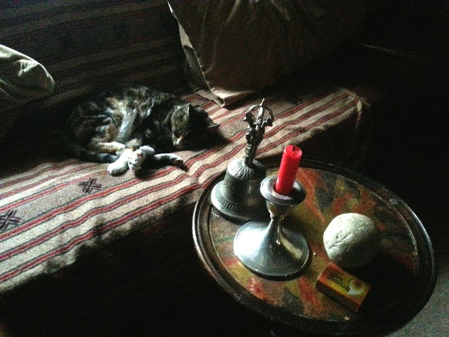
Once again  the comfort of my thick socks  this cold morning |  | between the clock’s tick  and the cat’s purrs  stillness settles
crack in the rock  clutching a white pebble  I let go |  | always roaring  faintly in the background  tinnitus of bliss
If the clock stops  will my heart  still tick? |  | deep winter in an antique mirror I meet my future self
Saturday
The Dao De Jing – A tongue-tip taste
Stuart gave an introduction to one of the two foundational texts (4th to 5th century BCE) of what was to become Daoism (the other is the Zhuangzi). He came across it when he was just 14 and has always considered himself something of a Daoist although it was Zen that gave him his practice.
In the context of Chinese philosophy, Dao – literally ‘road’ or ‘way’ – refers to a spiritual practice or code of conduct. But here it indicates a generative source that brings into existence ‘the ten thousand things’; sometimes described by the concept of ‘ziran’ or self-ablaze. ‘Ziran’ is reflected in the Daoist ideal of ‘non-doing’ and the suchness of Buddhism.
We each read out one of the very short untitled chapters from his favourite translation by Stephen Addis and Stanley Lombardo. Sophie picked #17 and found great relevance in the 3rd line:
‘Great rising and falling - people only know it exists.
Next they see and praise. Soon they fear. Finally they despise.
Without fundamental trust there is no trust at all. Be careful in valuing words.
When the work is done, everyone says we just acted naturally.’

There was the suggestions that you could boil Zen down to this line about ‘trust’ or Shraddha (faith in Buddhism).Moving on to #18, it was pointed out that Daoism was pretty sour about moralisers and ethical professors and exhibited a big distrust of theorising:
‘Great Tao rejected: Benevolence and righteousness appear.
Learning and knowledge professed: Great Hypocrites spring up.’
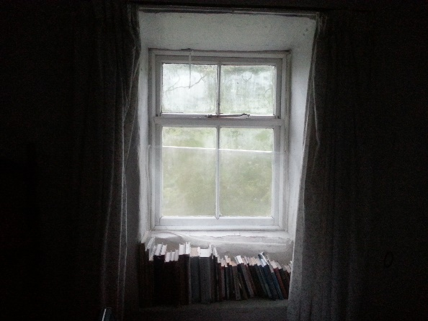

Leading George to pronounce William Blake a Zen mystic who had said something very similar:
‘Prisons built with bricks of law
Brothels with bricks of religion’

Fascinating but would we in Jane’s words ‘get back to the nuts’?
The nuts and bolts are the culture and mind-set of the Eastern way of life; the concept of the ‘naïve man’ who has no need to manipulate words. That is also the way of haiku: going with flow or the Wu Wei and crystallising the suchness with a lack of self-consciousness.
Movement with nature
In the garden, Sophie led exercises that enabled us to experience Yin (the negative and yielding) and Yang (the positive and advancing) through the body. This involved shifting weight from one leg to the other and feeling the supporting leg resting on the very centre of the earth.
This session had us bending and waving arms and even creating our own Tai Chi. Sophie explained that movement also operated on different sides of the brain; the analytical left side of the body controlling the right and the aesthetic and intuitive right side controlling the left.
The cats joined in. The ducks quacked gently.The session concluded with a section of the Tai Chi form called ‘Grasp the Sparrow’s Tail’. The four postures illustrate Tai Chi principles in action and in the movement there was a sense of integration: body and mind, right and left, yin and yang.
Maybe we caught a stray feather on the tail of the ‘whole mind’.
Sitting room
catching sight of sparrows
in the mirror

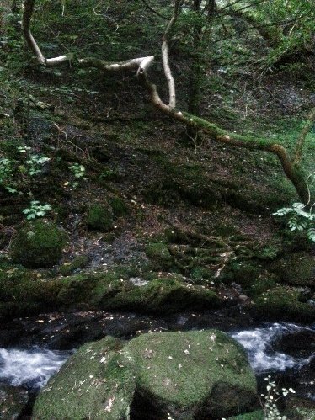

Contrasting qualities in imagery
George took the principles of Yin and Yang and looked at how this applied to the writing of haiku. He noted that ‘as for the yin and yang of imagery, Bassho claimed that “he always travelled with a copy of Chuang Tsu”. And he loved surprising innovative combinations. We looked at some examples:
My old body  a drop of dew grown  heavy at the tip Kiba | How gracefully  cows trample  fields of violets Fujio
Bush warbler  dropping on the rice cake  at the veranda’s edge Bassho | I have brought  a luminous piece of cloud  for your table of objects George Marsh
Bone scan  the length  of a Brandenburg Concerto Ken Jones | Cutting through it all  there’s no me and no person  just this itchy nose Bill Wyatt

A walk by Dolgoch Falls
In the afternoon we drove a short way to the beautiful Dolgoch waterfalls which cascade down a rocky wooded ravine in the mountainside. An easy walk up into the woods.
Mist rises  from the waterfall.  Dipper hunkers | Forever over the edge  countless dancing drops  pound the rock
Closed eyes  watching the waterfall  from a heather bed | The water falls  every drop stream and trickle  ends in the pool
Kingfisher  plundering the flow  for thousands of years | tumbling white water  the many tongues  of the river’s song  (for Martin Lucas)

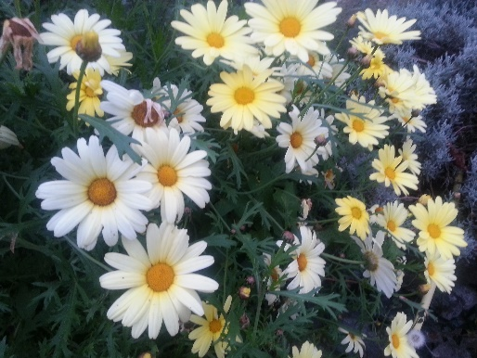
Sunday
Tribute to Ken
Off the top of his head Stuart quoted one of his favourite haiku by Ken, ‘To you, telephone pole A432756, I tip my hat’. And we took time on Sunday to do the same for Ken. In some respects Ken’s presence was very much part of the weekend. But then again so was his absence. As Martin said, ‘yes he is in our minds but it’s not the same thing.’
George recounted the founding of the Red Thread Sangha with Jim Norton and Sean O’Connor and explained that the name came from a koan by Ikkyu ‘Why can we not sever the red thread’; the red thread of passion!And we took turns to share memories; in Sophie’s case some lovely photographs from days up in the hills; Stuart read Ken’s haibun The Knife Grinder and Martin The Pull of the Tide. Jonathan a haibun by Bill Wyatt dedicated to Ken, and Jane readNoragh’s poem:
Death Haiku – a haiku sequence for Ken
By Noragh Jones

his final year
she learns to love
the bones beneath the skin

abandoned quarry
wild raspberries ripening
too late for him this year

funeral tea
Ken’s ghost flitting, knitting up
our unravelling selves

after the funeral
she watches the starling cloud
wheeling in to roost

walking alone
she listens for
his absent breathing

walking our mid-Wales hills
she turns to share a joke
forgetting he’s gone

And there were more haiku offerings:
Shuffling off this world  Meeting an old acquaintance  The harvest moon Bill Wyatt | Put it into words  That's shameful – reality  Constantly flows BW
Ken's Great Leap  into the all too clear  from the unknown George Marsh | how sweet, how strange  mizzle of delicate sadness  the heavens grey GM
Ancient child  still making sandcastles  on the turning tide Jonathan Buckley | I see the face  words carried off  on a brisk breeze JB
He’s not here, for sure!  working with his chisel  atop the mountain JB | That evening at sunset  the tide pulling away  waves rolling on Meg Griffiths
visually impaired
a crow walks by
and looks like you Jane Whittle

6-Beat Haiku
In our last major session, George challenged the traditional form of the haiku and asked us to contemplate new ways of defining it. And all of this because the traditional, albeit falsely conceived 5-7-5 format, could in his words ‘make people do silly things’ in order to conform.
Having said that, there were some great examples and practitioners who used the 5-7-5 format, not least Red Thread member Bill Wyatt. And others were mentioned including the American Richard Wright.
George first asked us to consider the work of Connaire Kensit who invented a new form called the Ei-haiku which uses 4-5-4 syllables per line. This on the grounds that a Japanese syllables expresses much less meaning and takes less time to say than an English syllable. Some examples:
Something stabs me –  stepped on in our room:  my late wife’s comb Buson | V for Victory  scrawled on the spring sky  geese flying north Connaire Kensit

Then he moved on to present the work of the Swedish Nobel prize-winning poet Tomas Transfromer who writes in 5-7-5 and uses quite a lot full stops. These haiku are taken from The Great Enigma. Here’s the blurb:‘… has now attained a prominence comparable to that of Pablo Neruda's during his lifetime. But if Neruda is blazing fire, Transtromer is expanding ice.’
The sun is low now.  Our shadows are giants.  Soon all will be shadow. | Death stoops over me.  I’m a problem in chess. He  has the solution.
The sea is a wall.  I can hear the gulls screaming –  they’re waving at us. | See how I’m sitting  Like a punt pulled up on land.  Here I am happy.

The response to both of these poets was muted and there was some concern that we might hurt George’s feelings. But it turned out that he was just softening us up for his pitch for the 6-beat haiku; 2 beats per line. To illustrate how this worked he used one of his own haiku and then a second.
 | 6-beat
Fleecy lamb  eaten away at the chest  full of rain | Fleecy lamb  hollowed out chest  full of rain
Switch off the phone  I’ll leave my love life  In the silence | Switch off the phone  I’ll leave my love  In the silence

Seemed to work very well.

Walking to the Broadwater Lagoon
In the afternoon we walked the estuary of the River Dysnni, past the new Tonfanau Bridge which connects up the Wales Coast Path and up towards theBroadwater lagoon, formed in the 19th century when the river silted up. Before that it was used for shipbuilding and trade in peat from the bogs.
Indian summer  the river running easy  to a lost horizon | Molecules at play  the sway  of the ocean call
The spine of hills  ripples lick  the estuary’s mud | Jelly disc  marooned in sun  salt-scented

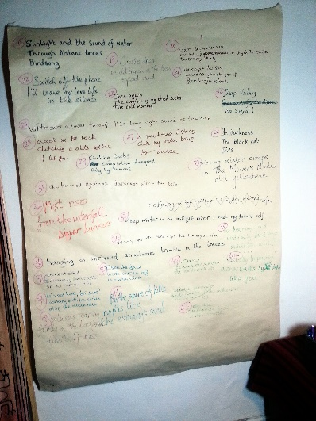

Haiku Workshops

On both the Friday, Saturday and Sunday evenings there was a haiku workshop led by Stuart. A chance to look at work and provide feedback to each other. These are some of the haiku reviewed.

Crashes down  an old branch as the trees  applaud wind | heavy at the reed tips the honesty of rain
The implausibility of it all –  yet here I am, stumbling home  under stars. | hanging on shrivelled strawberries tremble in the breeze
Moon round  window square  tracing the edges | autumnal equinox darkens within the bells
In darkness  The black cat  Dies | this long night without a lover, sound of surf
A multitude of stars  shake my sullen bones  to dance | warm September sun  curled up and dry in the curb  the orange leaf
looking at the sky
wondering how to get up
from the flower bed

Appendices

Useful references

Ikkyu and Red Thread: http://zentalks.blogspot.co.uk/2014/07/ikkyu.html
About the cook: http://wwzc.org/dharma-text/tenzo-kyokun-instructions-tenzo
‘Grasping the Sparrow’s Tail’: https://www.youtube.com/watch?v=dx-ZiITmsmo
About Zhuangzi: http://plato.stanford.edu/entries/zhuangzi/
Tao Te Ching by Lombardo & Aldiss: http://terebess.hu/english/tao/addiss.html

Graces

From Stuart:
We accept this food with gratitude
and share it in kinship with all beings in the Six Realms
so that together we may realise the reality of our lives,
the dream within the dream

From Sophie:
The Maenllwyd ' Mealtime Ceremonial '
At one with the food we eat, we identify with the universe.
At one with the universe we taste the food,
The universe and the food we eat partake of the same nature.
We share the merit of this food with all.
The first bite is to discard evil.
The second bite is to train in perfection.
The third bite is to help all beings,
We pray that all may be enlightened.

